Pizza Sales Analysis

Table of Contents

1. Problem Statement

2. Chart Requirements
2.1. Daily Sales Trend
2.2. Sales Revenue by Pizza Type
2.3. Hourly Orders Distribution
2.4. Average Order Value Over Time
2.5. Best and Worst Performing Pizzas
2.6. Forecast of Future Sales
2.7. Utilization of Seats by Hour

3. Business Questions Answered
3.1. What days and times do we tend to be busiest?
3.2. How many pizzas are we making during peak periods?
3.3. What are our best and worst-selling pizzas?
3.4. What’s our average order value?
3.5. How well are we utilizing our seating capacity?

4. Data Analysis Using SQL (DB Browser for SQLite)
4.1. Data Import
4.2. Data Cleaning
4.3. SQL Queries Used
- Total Orders by Pizza Type
- Total Revenue Generated
- Orders Distribution by Hour
- Average Order Value (AOV)
- Best and Worst-Selling Pizzas
- Daily AOV

5. Key Performance Indicators (KPIs)
5.1. Total Revenue
5.2. Total Orders
5.3. Average Order Value
5.4. Total Pizzas Sold
5.5. Average Pizzas Per Order

6. Marketing Strategies for Low-Selling Pizzas

7. Dashboard Snapshots
7.1. Dashboard 1
7.1.1 Overview

7.2. Dashboard 2

7.2.1 Overview

8. Tools, Software and Libraries Used

9. Conclusion

10. References

1. Problem Statement
Plato's Pizza, a local establishment, has been amassing over a year's worth of transactional data, but until now had yet to leverage it for data-informed decision making. Firm Desires Holistic Analysis of Sales Data to Allow for Useful Insights to Aid in Company Expansion. This project aims to explore the dataset using SQL (DB Browser for SQLite) and graph key performance indicators in Tableau. Doing an analysis of this while also identifying top-selling timings, tastes of customers and best- and worst-selling items would help in operational and strategic improvement.

2. Chart Requirements
Several visualizations were built to turn the raw transactional data into actionable business insight. These graphical representations are filtered for specific business questions to make efficient data-driven decisions. All data you see are the SQL queries pulled from DB Browser for SQLite and a visual representation of that data created in Tableau for better readability and design.
The analysis touched upon some of the major of requirements chart wise:

2.1. Daily Sales Trend
- Purpose: To monitor daily revenue and identify sales patterns across the month.
- Tool: Tableau (Line Chart)
- SQL Support: Aggregated daily revenue using SUM(field6 * field4) grouped by order_date.

2.2. Sales Revenue by Pizza Type
- Purpose: To determine which pizzas are the top contributors to overall revenue.
- Tool: Tableau (Horizontal Bar Chart)
- SQL Support: Summed total revenue grouped by pizza_id.

2.3. Hourly Orders Distribution
- Purpose: To identify peak hours of customer demand.
- Tool: Tableau (Bar Chart)
- SQL Support: Grouped order quantities by extracting the hour from the order_time.

2.4. Average Order Value Over Time
- Purpose: To monitor the consistency of customer spending per order.
- Tool: Tableau (Line Chart)
- SQL Support: Calculated AVG(field6 * field4) across all orders.

2.5. Best and Worst Performing Pizzas
- Purpose: To highlight the highest and lowest selling pizzas by order count.
- Tool: Tableau (Bar Chart)
- SQL Support:
  - Best: Top 5 pizzas by SUM(quantity) in descending order.
  - Worst: Bottom 5 pizzas by SUM(quantity) in ascending order.
2.6. Forecast of Future Sales
- Purpose: To predict upcoming sales volumes for proactive planning.
- Tool: Tableau (Forecast Line Chart)
- SQL Support: Historical sales values used as input for Tableau’s built-in forecasting model.

2.7. Utilization of Seats by Hour
- Purpose: To explore efficiency in seating and kitchen resource usage.
- Tool: Tableau (Line & Heat Chart)
- Note: While not directly derived from the dataset, this was inferred through order volume trends by hour.

3. Business Questions Answered

3.1. What days and times do we tend to be busiest?
According to the “Busiest Days” chart, Fridays and Saturdays show the highest volume of orders, followed closely by Thursdays. These are the peak days for pizza orders.
The “Orders per Hour” chart reveals that 12 PM (lunch) and 7 PM to 8 PM (dinner) are the busiest times of day. These peaks align with common mealtimes, suggesting a high demand during lunch and dinner hours.

3.2. How many pizzas are we making during peak periods?
The peak periods, identified around 12 PM and 7 PM, show up to 6,776 pizzas being made in just one hour (as seen in the “Orders per Hour” chart). This indicates significant operational load during those hours, requiring efficient kitchen management and staffing.

3.3. What are our best and worst-selling pizzas?

Based on the SQL analysis and charts:
Best-selling pizzas include:
- The Classic Deluxe Pizza – 2,453 orders
- The Barbecue Chicken Pizza – 2,432 orders
- The Hawaiian Pizza – 2,422 orders
Worst-selling pizzas include:
- The Brie Carre Pizza – 490 orders
- The Mediterranean Pizza – 934 orders
- The Spinach Supreme Pizza – 982 orders
These insights were derived from the “Top 5 Best-Selling” and “Bottom 5 Worst-Selling” pizza charts created using SQL queries on (pizza_id) and (quantity).

3.4. What’s our average order value?
The “Average Order Value” (AOV) chart shows that the average value of an order is approximately $16.20, calculated using the SQL query:

SELECT AVG(field6 * field4) AS avg_order_value
FROM "Data Model - Pizza Sales";

The AOV is consistent across different hours, with minor fluctuations. This metric is important for understanding customer spending habits.

3. 5. How well are we utilizing our seating capacity?
The “Utilization of Seats by Hour” chart shows that utilization peaks between 12 PM and 2 PM, and again between 6 PM and 8 PM, which aligns with order spikes.

Assuming the store has 15 tables and 60 seats, and considering the number of orders, seat utilization reaches up to 4,200 orders/hour at peak. This suggests that during peak hours, seating is likely near full capacity, indicating efficient utilization of space.

4. Data Analysis Using SQL (DB Browser for SQLite)

4.1Data Import
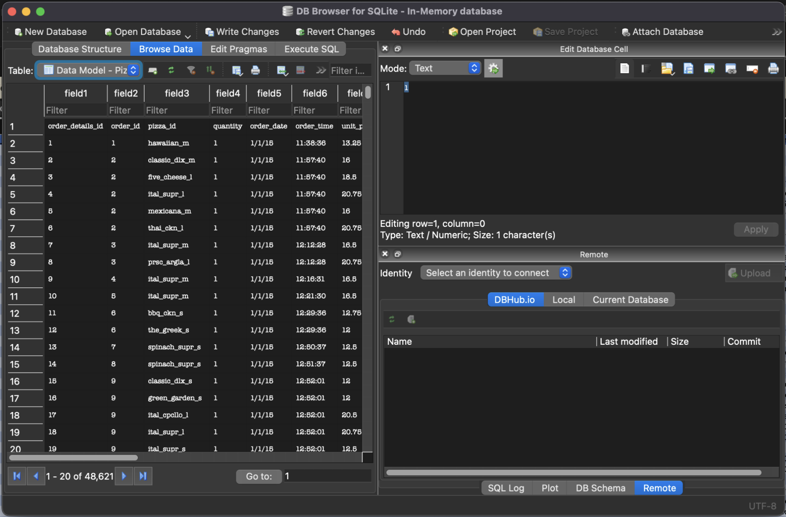
4.2 Data Cleaning
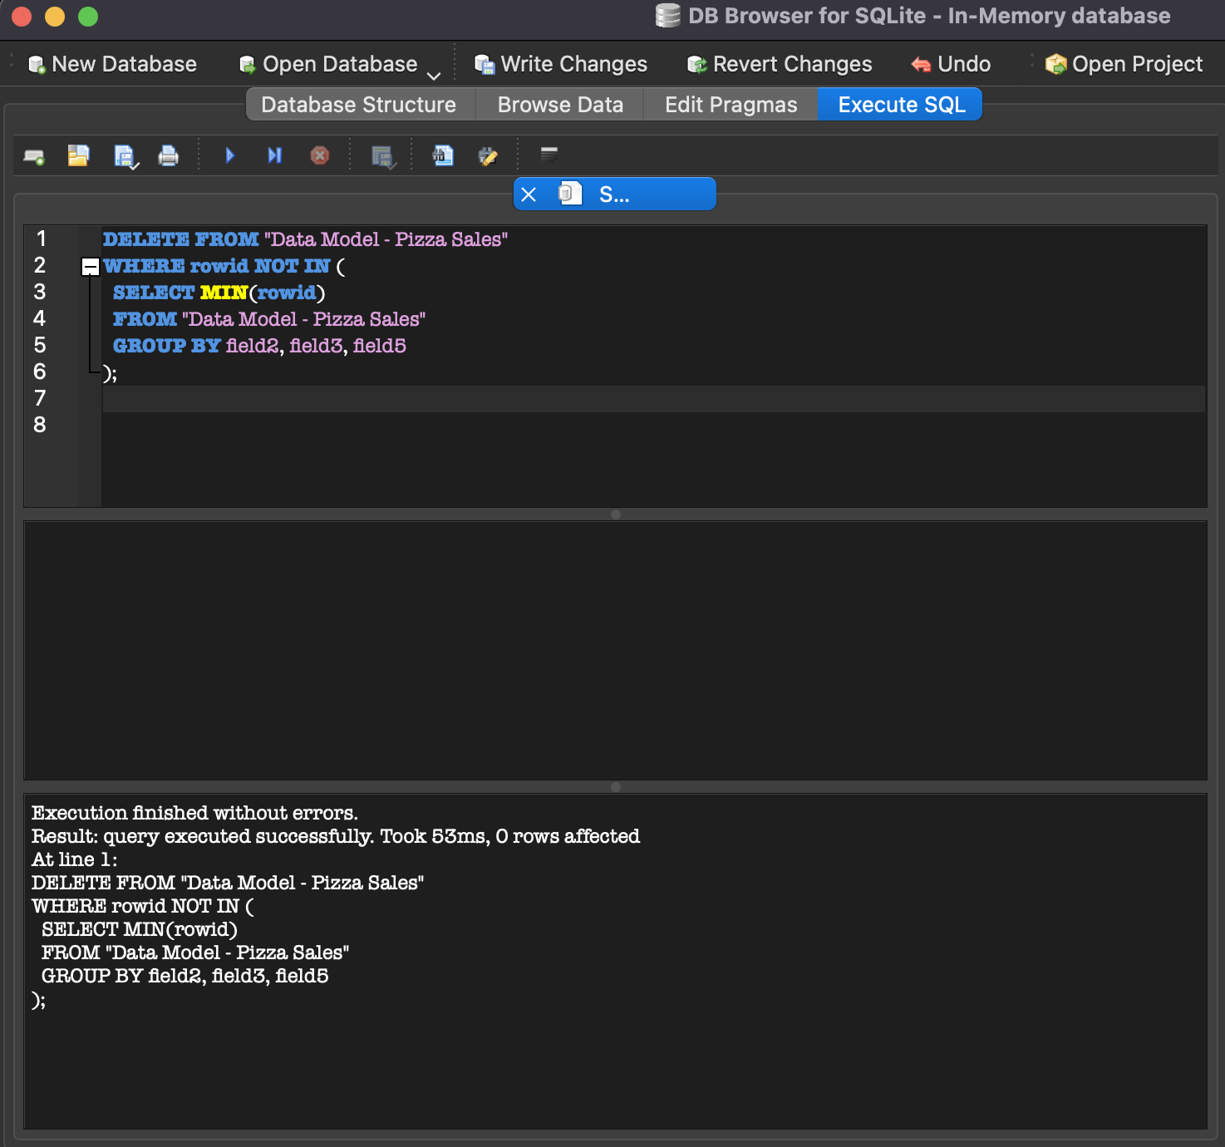

4.3 SQL Queries Used
Total Orders by Pizza Type
SELECT field3 AS pizza_id, SUM(field4) AS total_orders
FROM "Data Model - Pizza Sales"
GROUP BY field3
ORDER BY total_orders DESC;
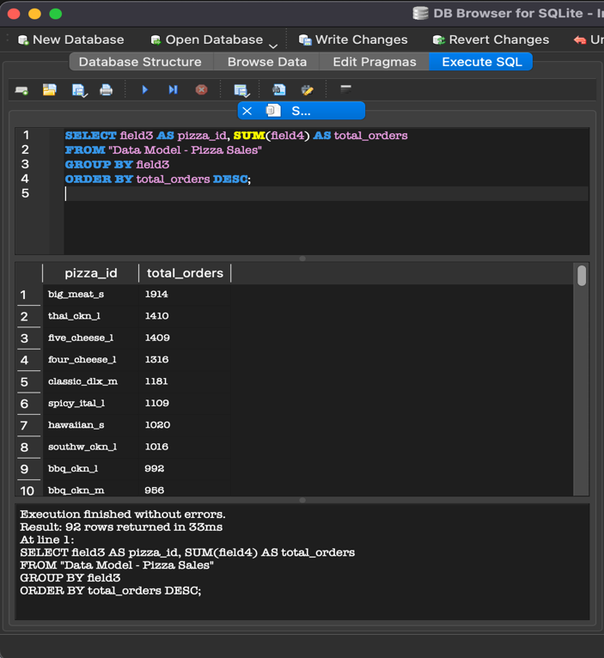

Total Revenue Generated
SELECT SUM(field6 * field4) AS total_revenue
FROM "Data Model - Pizza Sales";
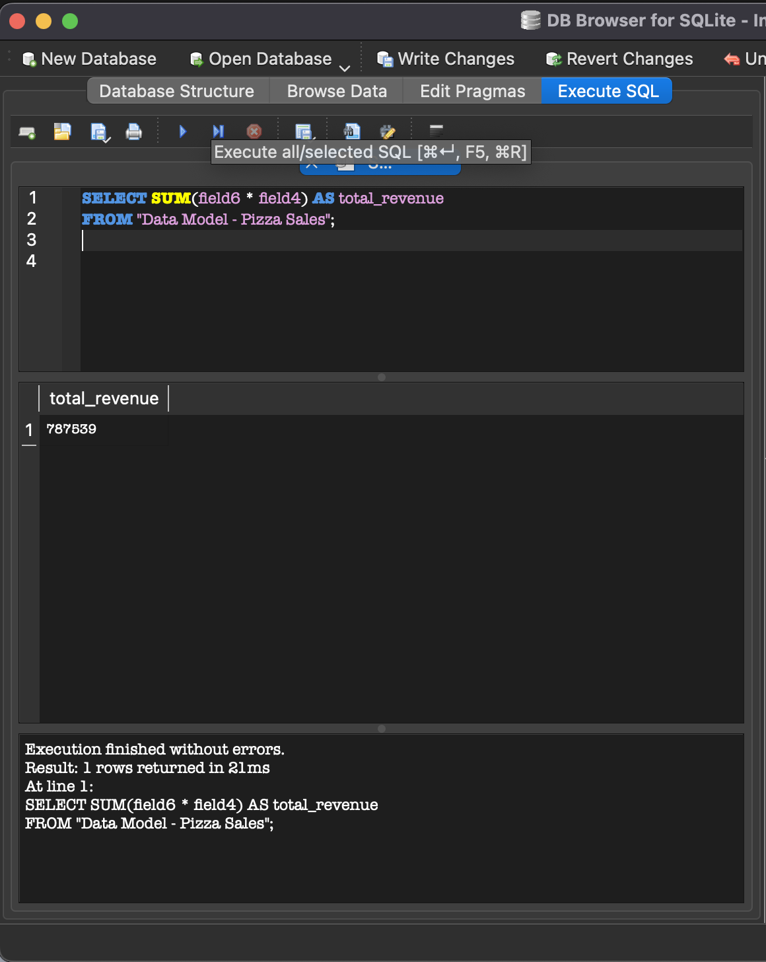

Orders Distribution by Hour
SELECT
SUBSTR(field6, 1, 2) AS order_hour,
SUM(field4) AS total_orders
FROM "Data Model - Pizza Sales"
GROUP BY order_hour
ORDER BY order_hour;

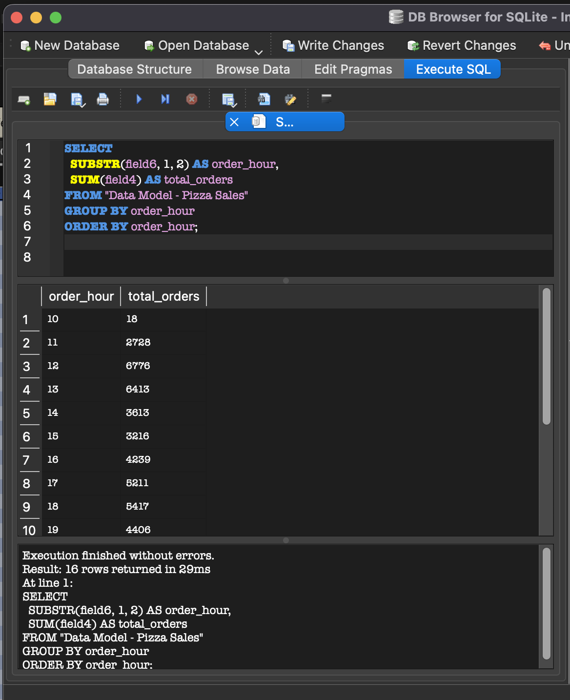

Average Order Value (AOV)

SELECT AVG(field6 * field4) AS avg_order_value
FROM "Data Model - Pizza Sales";
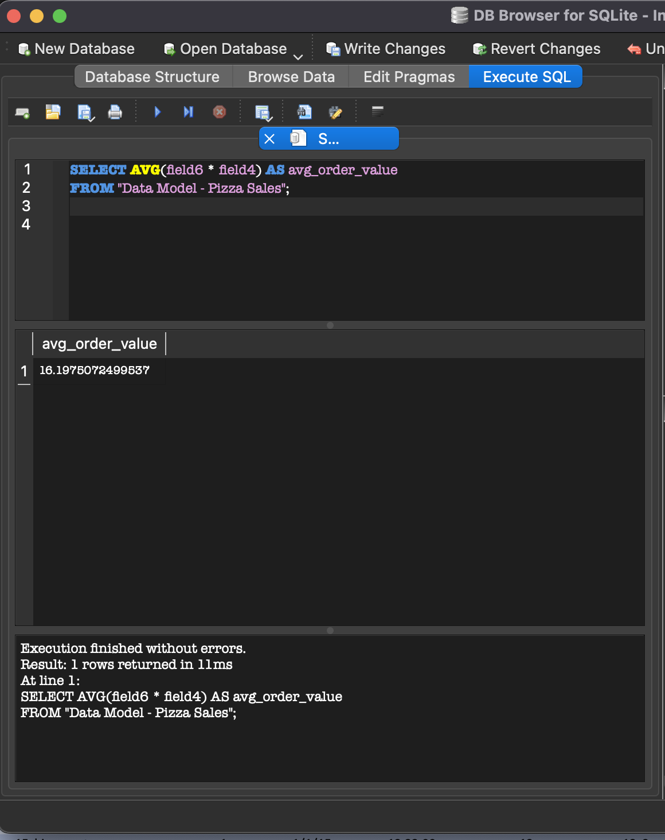

Top 5 Best-Selling Pizzas
SELECT field3 AS pizza_id, SUM(field4) AS total_orders
FROM "Data Model - Pizza Sales"
GROUP BY field3
ORDER BY total_orders DESC
LIMIT 5;

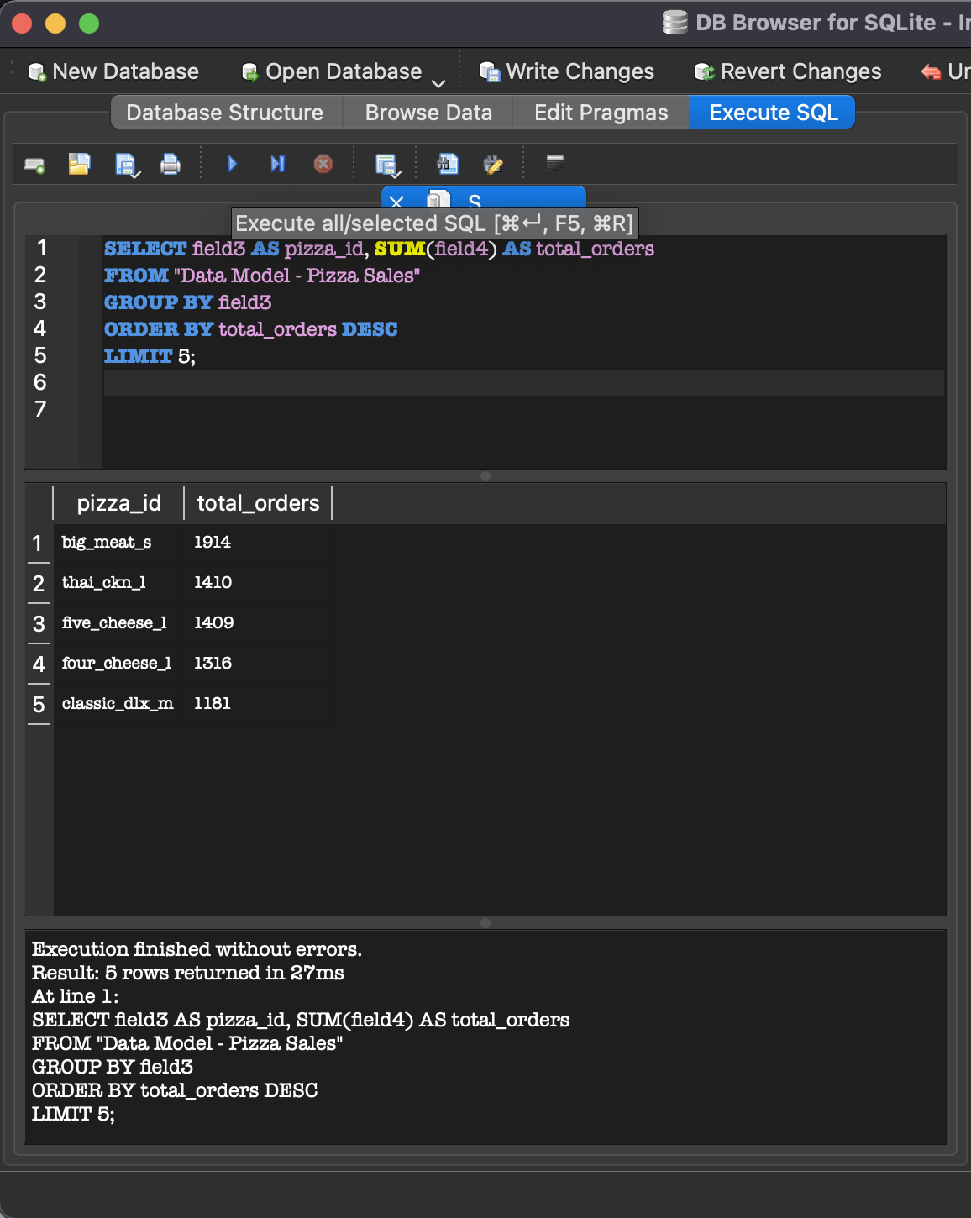

Bottom 5 Least-Selling Pizzas

SELECT field3 AS pizza_id, SUM(field4) AS total_orders
FROM "Data Model - Pizza Sales"
GROUP BY field3
ORDER BY total_orders ASC
LIMIT 5;

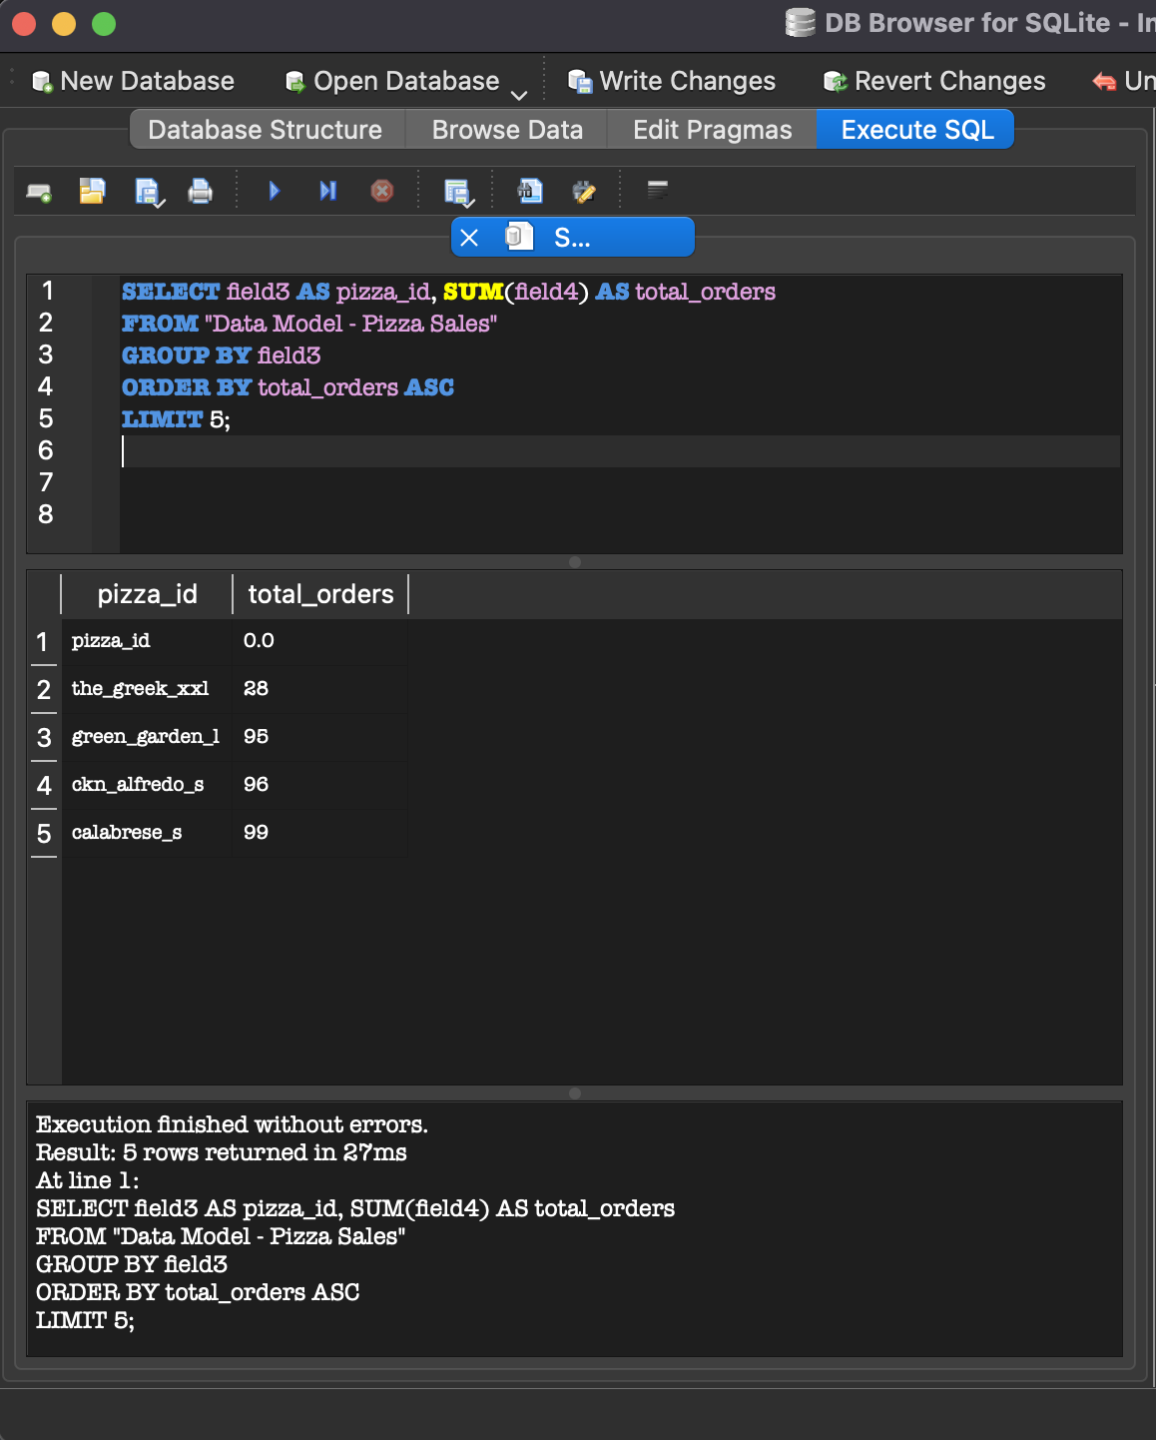

Daily Average Order Value (AOV)
SELECT
field5 AS order_date,
ROUND(SUM(field6 * field4) / COUNT(DISTINCT field2), 2) AS avg_order_value
FROM "Data Model - Pizza Sales"
GROUP BY field5
ORDER BY order_date;

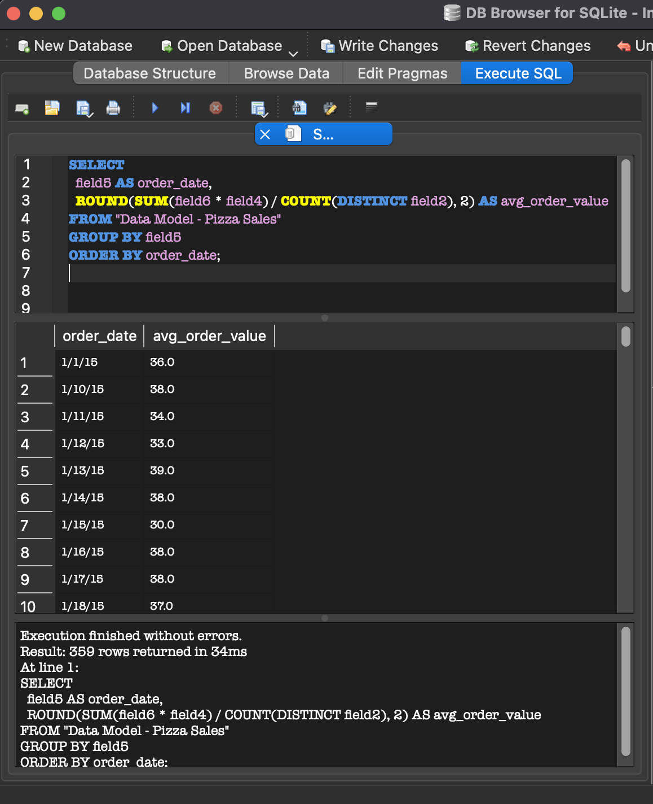

5.Key Performance Indicators (KPIs)

5.1. Total Revenue

SELECT SUM(field6 * field4) AS total_revenue
FROM "Data Model - Pizza Sales";

Result: $787,539

5.2. Total Orders

SELECT COUNT(DISTINCT field2) AS total_orders
FROM "Data Model - Pizza Sales";
Result: 21,350

5.3. Average Order Value (AOV)
AOV = Total Revenue / Total Orders

SELECT AVG(field6 * field4) AS avg_order_value
FROM "Data Model - Pizza Sales";

Result:$16.20

5.4. Total Pizzas Sold

SELECT SUM(field4) AS total_pizzas_sold
FROM "Data Model - Pizza Sales";

Result: 48,621

5.5. Average Pizzas Per Order
Avg Pizzas per Order = Total Pizzas Sold / Total Orders

SELECT ROUND(SUM(field4) * 1.0 / COUNT(DISTINCT field2), 2) AS avg_pizzas_per_order
FROM “Data Model – Pizza Sales”;

Result: ~2.28 pizzas per order

6. Ways of Marketing Tortures which are sold the least

Run Promotional Offers:
Provide "2 Same Product for Price of 1", "Half Price" or Trial offers.
Offer first-time customers a Refer a Friend Discount on select pizzas.

Highlight in the Menu:
Advertise them as "Chef's Special", "Staff Pick" or "Must Try This Week" to make them jump off the menu.

Add to Combo Deals:
Combine non-selling pizzas with popular pizzas or beverages at a discount price (e.g., Combo for Two).

Gather Customer Feedback:
Ask for comments about why the pizza is not the first choice—taste, ingredients, price—and revise accordingly.

Seasonal or Themed Variations:
Make sure to design or alter pizza recipe to fit the holidays or themes going viral (like Spicy August Edition).

Rethink or Take Away
When one pizza consistently underperforms, you might consider either removing it from the lineup for a time or filling the void with experimental new flavors.

7. Dashboard Snapshots

7.1Dashboard-1
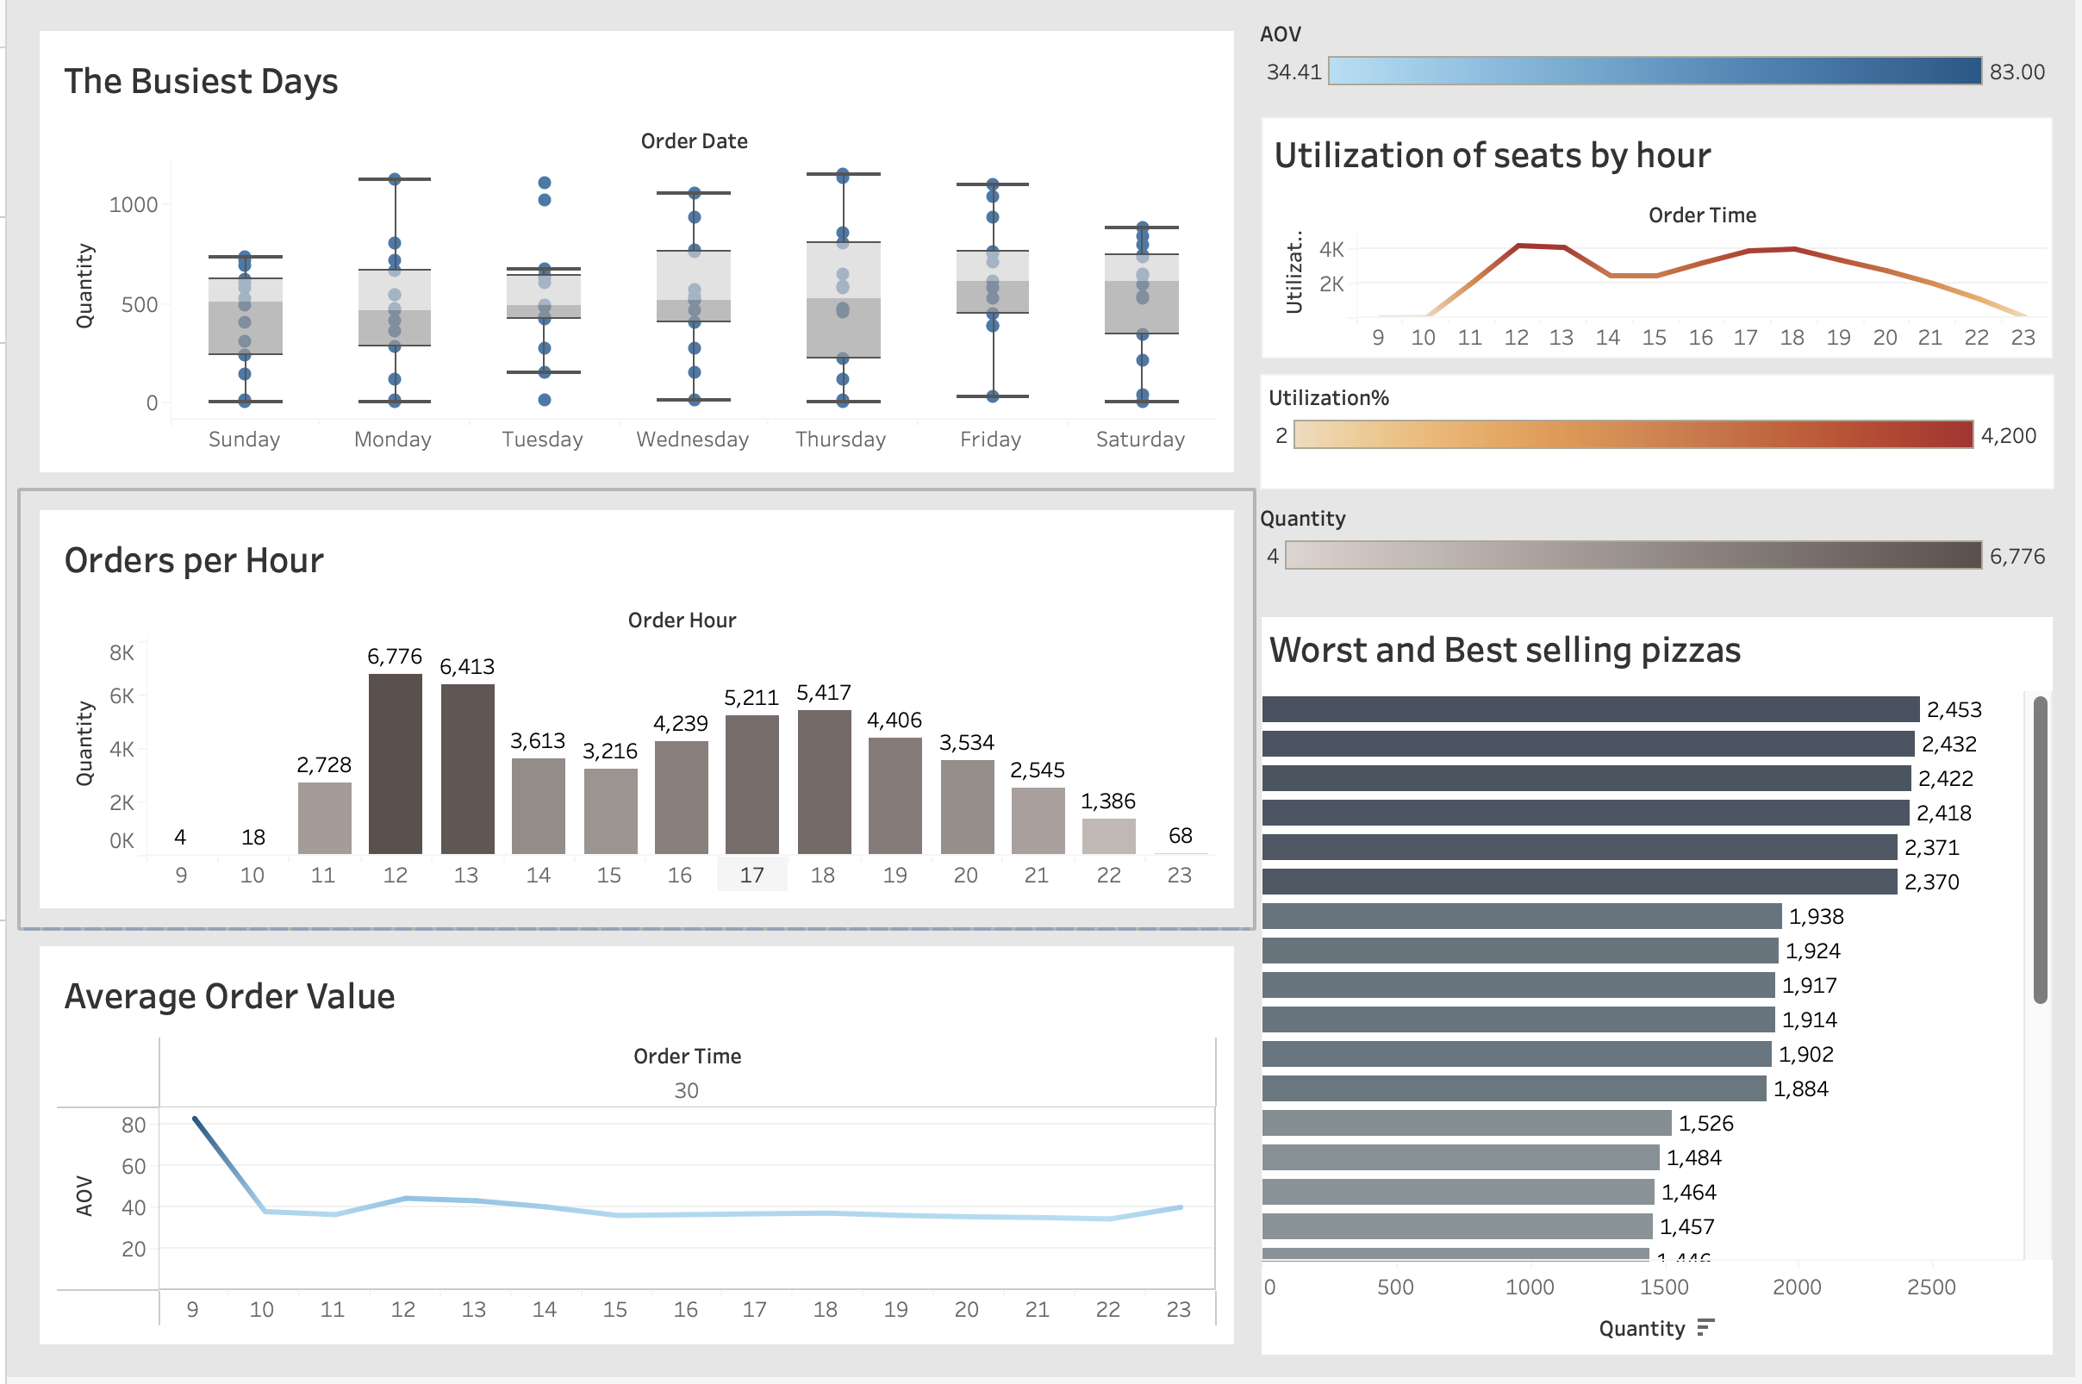

7.1.1 Overview:
The dashboard provides a quick summary of pizza sales performance. It highlights:
- Total Sales Revenue – The overall income from pizza sales.
- Total Pizzas Sold – The number of pizzas sold during the selected time frame.
- Best-Selling Pizzas – A ranked list of the top-performing pizza types.
- Sales Trends Over Time – Visuals showing how sales have changed monthly or weekly.
- Sales by Category – Breakdown of sales by pizza type.

7.2 Dashboard-2

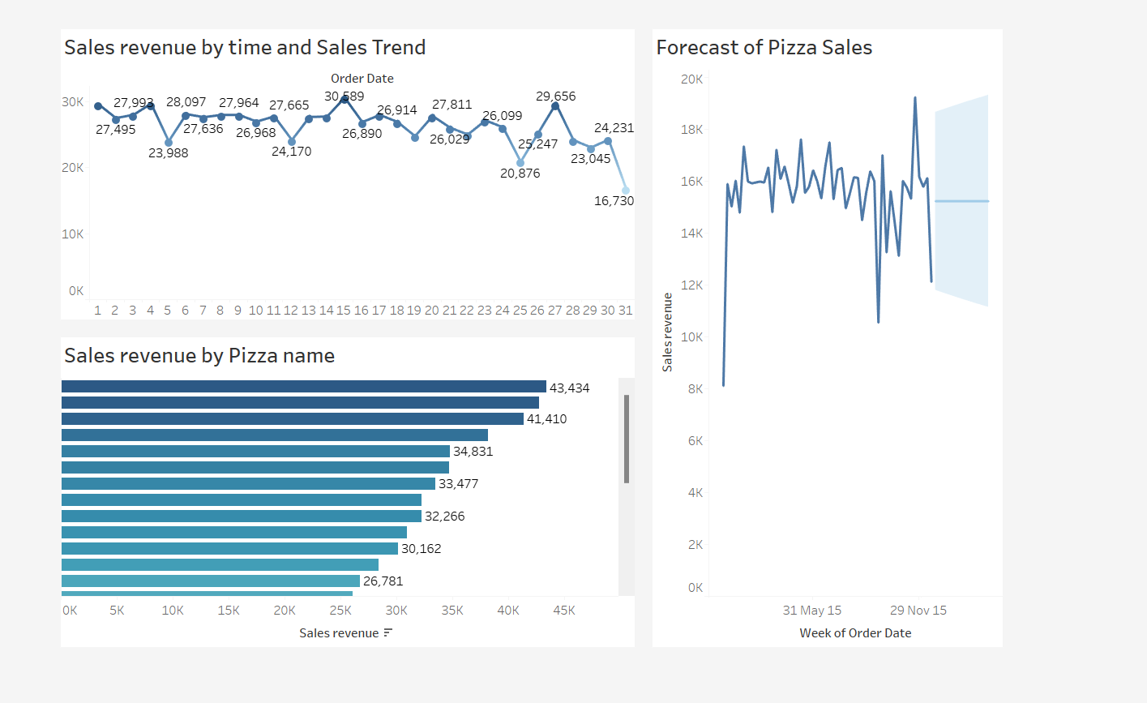

7.2.1 Overview:
The dashboard provides a quick summary of pizza sales performance. It highlights:
- Sales revenue and trend by time
- Sales revenue by Pizza name
- Forecast of Pizza Sales
Insights from the above Dashboard
- The Thai, BBQ, California Chicken Pizzas are having revenue by Pizza. So, by investing in them can get you more sales.
- The Brie Carre and Green Garden Pizzas are low Sale Pizza. So, based on that we should play safe side on selling those pizzas.
- Some of the Pizzas are Seasonal based on that the inventory should be ready to attract the Customers.
- Based on these insights We can increase the Sales of the Pizzas effectively.

8. Tools, Software and Libraries

- DB Browser for SQLite
It is utilized for efficient data storage, query execution, and operations like data cleaning.
- Tableau 2025.1
Used for dashboard maker of interactive dashboards and visualization of main business insights like best selling products, sales trends, execution analysis.
- Microsoft Excel 2021
It is used for initial data pre-processing, exploration and transformation purposes before loading into the database.

Conclusion:
The analysis of Plato’s Pizza sales data reveals that peak business occurs on Fridays and Saturdays around lunch and dinner hours. Top-performing pizzas like the Classic Deluxe dominate sales, while low-sellers such as the Brie Carre offer opportunities for targeted marketing or menu revisions.
Key metrics include an average order value of $16.20, 48,621 pizzas sold, and $787,539 in revenue, indicating solid performance and strong customer demand. Forecasting and seat utilization trends further support strategic planning for staffing and expansion.
Overall, the data empowers Plato’s Pizza to make informed decisions, enhance operations, and improve profitability.

9. References

https://www.youtube.com/@datatutorials1

Tableau (2023). Best Practices for Building Effective Dashboards. Tableau Whitepaper.
https://www.tableau.com/learn/whitepapers/best-practices-effective-dashboards

